**Logistic Regression:**

Logistic Regression is one of the most important model in machine learning that we ofen be using in our projects and used cases.

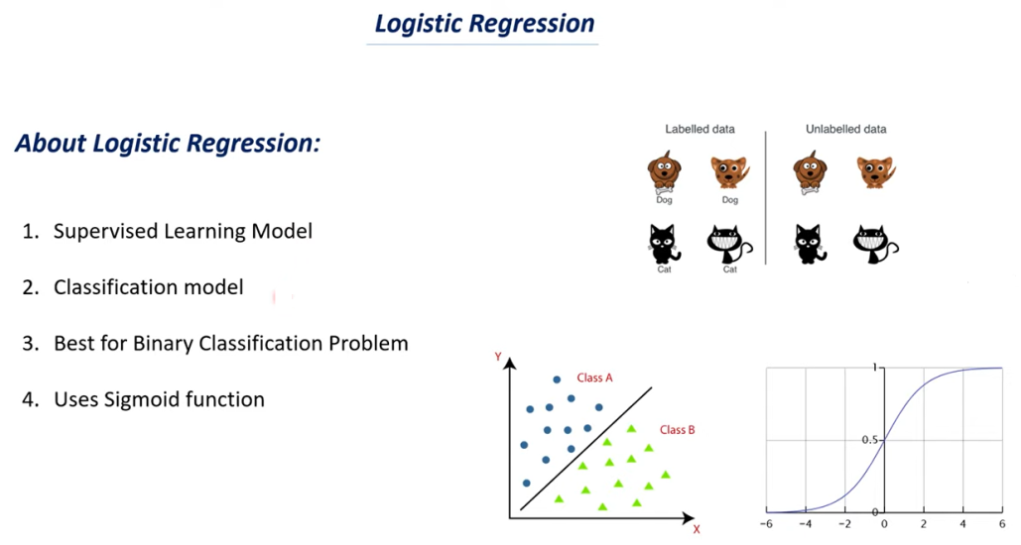

**Sigmoid Curve:**

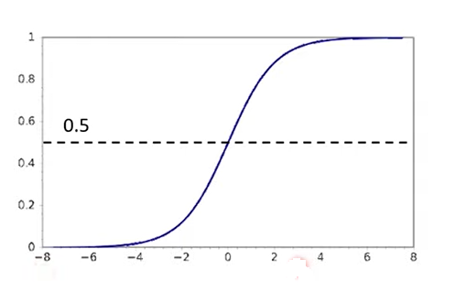

* Let’s say that we have sigmoid curve here or let’s say that this is the logistic regression curve.
* If you see here y –axis values range from 0 to 1 and x -axis values can be negative to positive.
* Exactly at the mid-point you will have y value as 0.5 this is the part which separate the curve into two equal half’s.
* The data points which comes under above part takes the label as ‘1’ and the data points which comes under below part takes the label as ‘0’.

Let’s understand the equation of sigmoid curve.

* Let’s take on x axis values of ‘Z’ and on the y axis we take the values as ‘Y^’(Y cap).

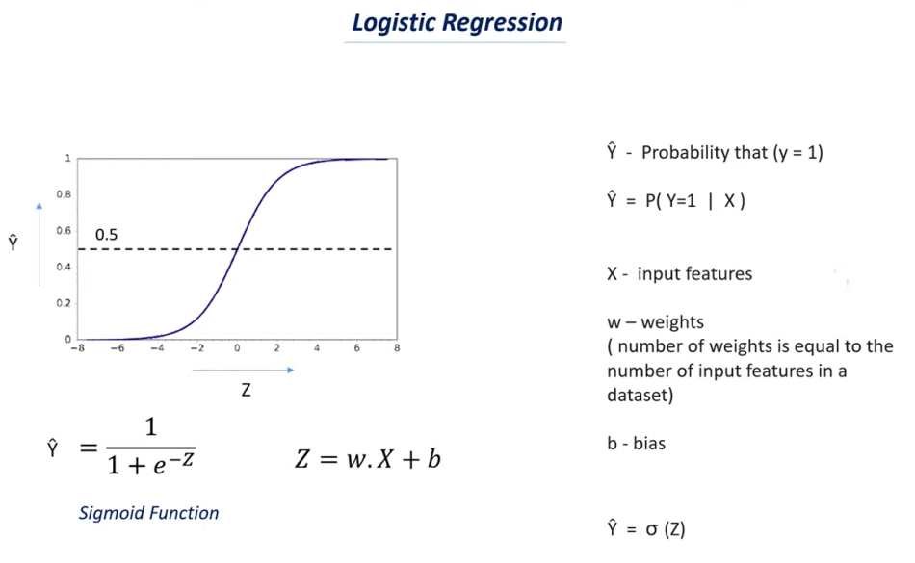

Understanding sigmoid curve.

1. 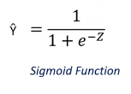 This is the equation of the sigmoid curve.

2.  Which represents the equation of simple line where w is slope and b is intercept.

W is the weight and b is bias.

3. Let’s understand what all this terms represents are

- Y cap – represents the probability that Y=1.

* Let’s take an example if you get the y cap value as 0.8 that means there is a 80% chance that your y value will be ‘1’.
* Let’s take another example that your y cap value is 0.2 that means there is only 20% chance that y value will be ‘1’ and there is 80% chance that your y value will be ‘0’.
* In case of linear regression we would have written it as y = mx+c but in case of logistic regression we won’t take y i.e we won’t take the actual value of ‘y’ but we will take the value of y cap.
* Because we are finding the probability of y being ‘1’.
* In case of linear regression we try to find the accurate value.
* We can also write this in different way that is represent as 

i.e Y cap equal to P of Y=1 bar X

Where Y cap represent the probability of Y being ‘1’.

‘P’ means probability.

**How to read this particular line is **

Y cap equal to the probability of Y=1 for a given value of X.

Where X is the input features and you can have several features.

The final outcome will be our output value.

We also write this sigmoid equation as 

i.e Y cap equal to sigma (Z).

this sigma represents as 

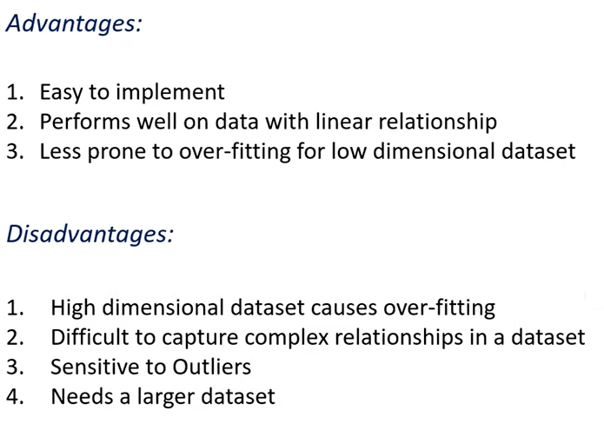

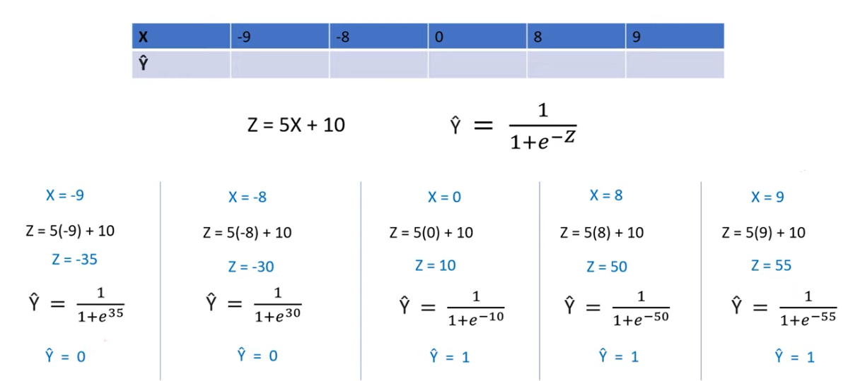

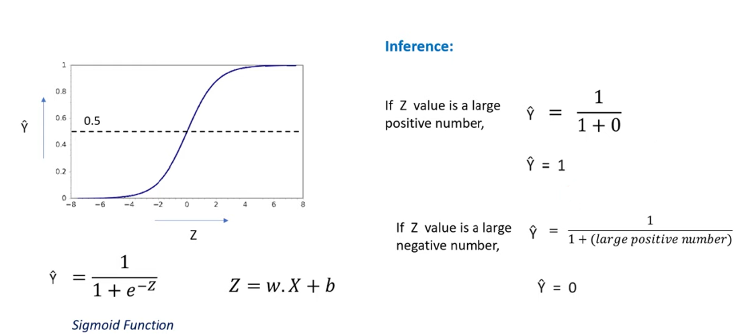

Z=wX+b

* W & b are called as model parameter of the logistic Regression model.
* Our machine learning model try’s to find the optimal value for weight and bias.
* It will try to find what will be the best values for weight and bias so that it can accurately predict the Y cap value.
* If your weight value and bias values are not proper they are not optimum you won’t get proper Y cap value.

